E-learning
The Department of Mechanical Engineering has initiated e-classrooms for final year students.
1.As per curriculum, technical seminar and project seminar are arranged for final year students.In this, for each seminar by a student or a group of students, all the students of the class are required to be present or attend. After the seminar by a student, the students in the class are randomly asked to sum up the seminar contents. Students are also encouraged to raise questions and the best questions are appreciated. It is observed that this practice has improved the attention of the student in the seminars and better engaged them in discussions on newtechnology in their field of study.

2. About 50% of the final year students carry out in-house project work. Through such in-house
Projects, students are encouraged to innovate and come up with new ideas. Faculty assists
Students in formulating their ideas for the design and development of projects. In many of the
Projects, the students are encouraged to utilize the college laboratories.

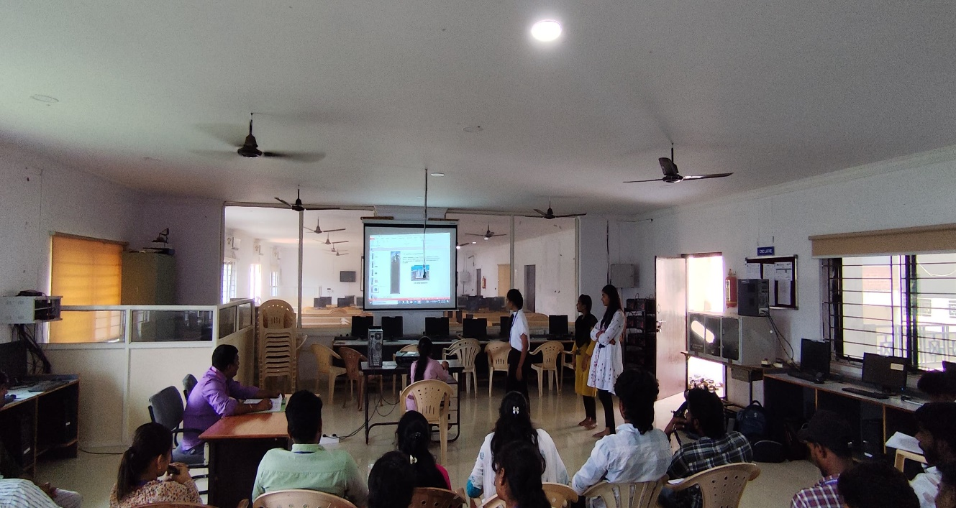
IV – Year Mechanical students project review

Innovations by Faculty in Teaching and Learning
The faculty actively conducted a teaching session using a PowerPoint presentation to enhance students’ understanding of the subject. This approach reflects the department’s commitment to integrating innovative methods in teaching and learning, moving beyond traditional lecture-based methods.

Innovation in Teaching:
- Use of Multimedia Tools:
  - The faculty utilized a projector and PowerPoint presentation to visually demonstrate complex concepts, making the session more interactive and engaging.
  - Diagrams, images, and animations were used to explain the working of mechanical components such as screw compressors, helping students grasp intricate mechanisms effectively.
- Interactive Teaching Approach:
  - The session encouraged student interaction through questions and discussions.
  - Practical examples were integrated into the presentation to relate theoretical concepts to real-world applications.
- Blended Learning Strategy:
  - The combination of visual aids and verbal explanations ensured that students with different learning styles could benefit.
  - Digital teaching tools supplemented traditional classroom teaching, making the learning process more dynamic.
- Focus on Conceptual Clarity:
  - The faculty emphasized step-by-step working principles of mechanical systems.
  - Critical points were highlighted in the slides, aiding memory retention and comprehension.
Impact on Students:
- Improved engagement and understanding of complex mechanical concepts.
- Enhanced ability to visualize and interpret mechanical systems.
- Encouraged active participation and curiosity among students.

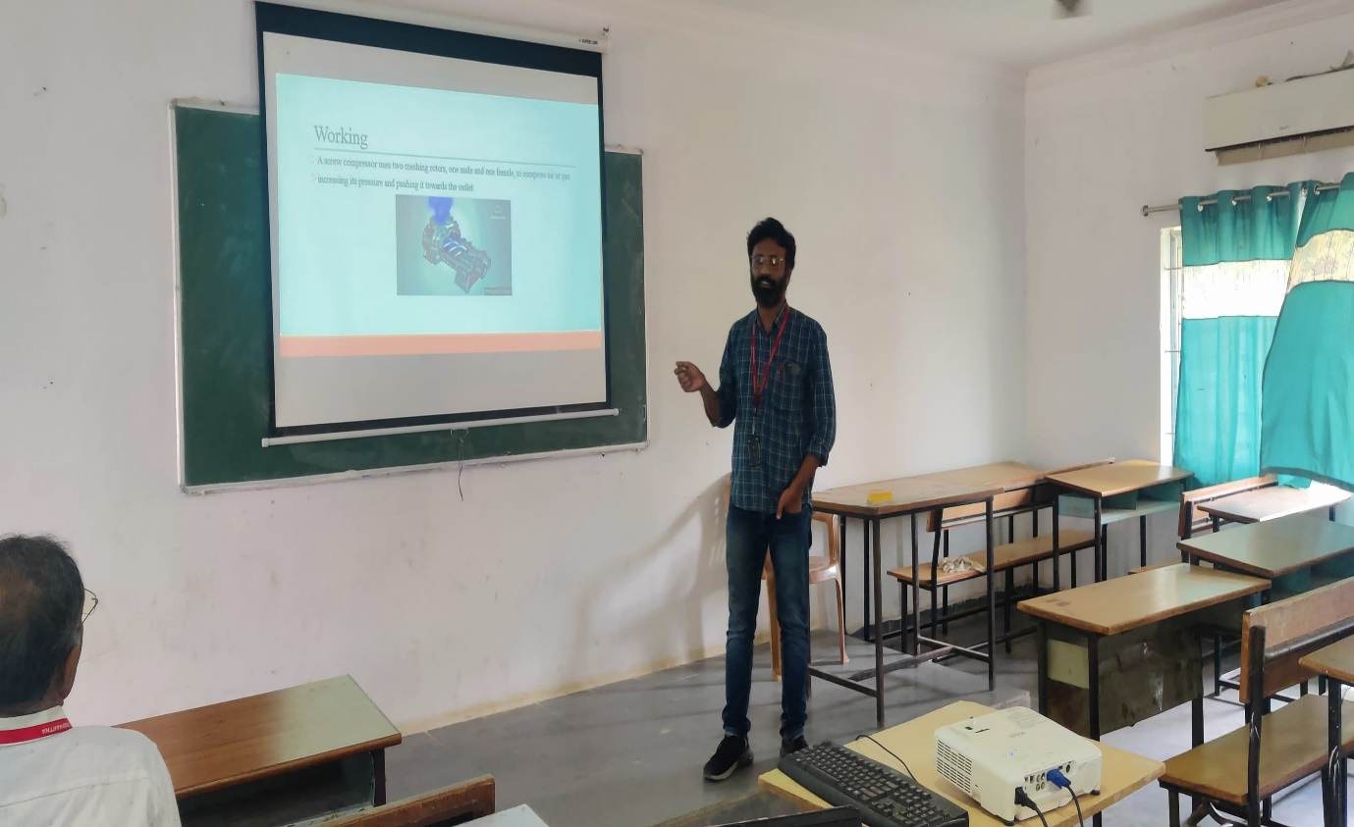

Conclusion:
The adoption of PowerPoint presentations and multimedia tools represents a significant innovation in teaching and learning practices within the department. These methods not only make learning more interactive and effective but also prepare students for practical application of theoretical knowledge. Continuous use of such innovative teaching strategies will further enhance academic outcomes and student engagement.

